EC Declaration of Conformity
In accordance with EN 45014

We: DK-Technologies

of Marielundvej 37D – 2730 Herlev - Denmark

declare under our sole responsibility that the product

Equipment type Compact™ Varitime Sync Generator
Model name PT 5202

Serial number

to which this declaration relates is in conformity with the following standard(s) or other normative document(s)

IEC 61010-1 / EN61010-1: 2001 (2nd edition) – Safety Requirements

EN 55103-1/1996 - Emission

EN 55103-2/1996 - Immunity

EN61000-3-2/1995 – Harmonics

EN61000-3-3/1995 – Voltage Fluctuations

in accordance to the following Directives:

73/23/EEC Low Voltage Directive (and its amending directives)

89/336/EEC Electromagnetic Compatibility Directive (and its amending directives)

Signed by:
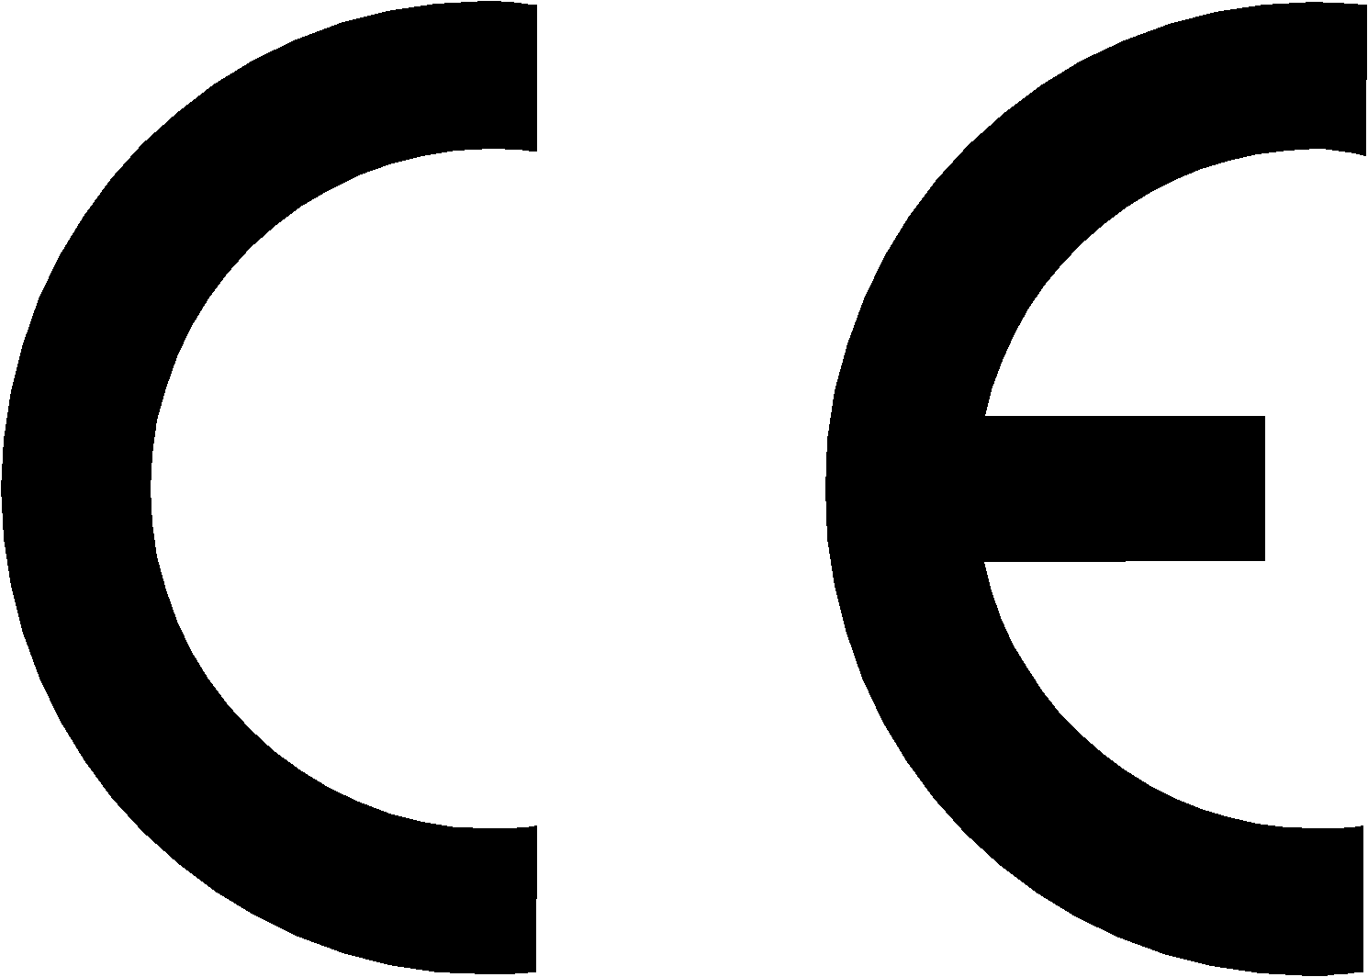

Name: Karsten Hansen

Position: CEO

Done at: Marielundvej 37D

Date: 18-03-2005

